

All Faiths Children’s Academy

24th February 2026

Dear Parents and Carers

PARENT/CARER MEETINGS FOR RECEPTION

On Tuesday 24th March (3.30pm – 6pm) and Thursday 26th March (15.30 – 6pm) we will be hosting parent consultations for Reception class.
The online booking system will become live at 8pm on Monday 16th March 2026. You can book a slot through the Arbor App.
Meetings will take place in school and will last for 10 minutes. Booking closes on Monday 23rd March at 5pm.
Please call the school office on 03333 602 100 if you would like to have a meeting with Mrs Bravo (SENCO).

Kind regards
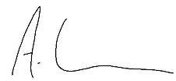
Mr Kershaw
Headteacher

